**Aim:** Data Structures using R

**IDE:** R Studio

**Theory:**

A data structure is a particular way of organizing data in a computer so that it can be used effectively. The idea is to reduce the space and time complexities of different tasks. Data structures in R programming are tools for holding multiple values.

R’s base data structures are often organized by their dimensionality (1D, 2D, or nD) and whether they’re homogeneous (all elements must be of the identical type) or heterogeneous (the elements are often of various types). This gives rise to the six data types which are most frequently utilized in data analysis.

The most essential data structures used in R include:

* **Vectors**
* **Lists**
* **Dataframes**
* **Matrices**
* **Factors**

### Vectors

A vector is an ordered collection of basic data types of a given length. The only key thing here is all the elements of a vector must be of the identical data type e.g homogeneous data structures. Vectors are one-dimensional data structures.

### Lists

A list is a generic object consisting of an ordered collection of objects. Lists are heterogeneous data structures. These are also one-dimensional data structures. A list can be a list of vectors, list of matrices, a list of characters and a list of functions and so on.

### Dataframes

Dataframes are generic data objects of R which are used to store the tabular data. Dataframes are the foremost popular data objects in R programming because we are comfortable in seeing the data within the tabular form. They are two-dimensional, heterogeneous data structures. These are lists of vectors of equal lengths.

Data frames have the following constraints placed upon them:

* A data-frame must have column names and every row should have a unique name.
* Each column must have the identical number of items.
* Each item in a single column must be of the same data type.
* Different columns may have different data types.

### Matrices

A matrix is a rectangular arrangement of numbers in rows and columns. In a matrix, as we know rows are the ones that run horizontally and columns are the ones that run vertically. Matrices are two-dimensional, homogeneous data structures.  
Now, let’s see how to create a matrix in R. To create a matrix in R you need to use the function called matrix. The arguments to this matrix() are the set of elements in the vector. You have to pass how many numbers of rows and how many numbers of columns you want to have in your matrix and this is the important point you have to remember that by default, matrices are in column-wise order.

### Factors

Factors are the data objects which are used to categorize the data and store it as levels. They are useful for storing categorical data. They can store both strings and integers. They are useful to categorize unique values in columns like “TRUE” or “FALSE”, or “MALE” or “FEMALE”, etc.. They are useful in data analysis for statistical modeling.

Now, let’s see how to create factors in R. To create a factor in R you need to use the function called factor(). The argument to this factor() is the vector.

**Program:**

Write the program (R script) to demonstrate the functionality of:

1. Vectors
2. Lists
3. Dataframes
4. Matrices
5. Factors

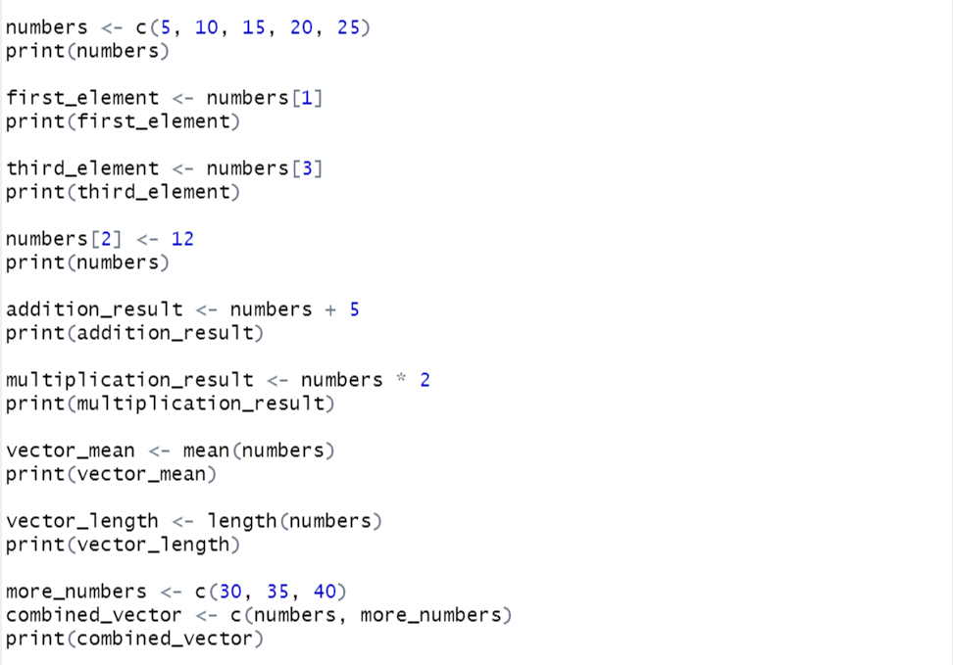

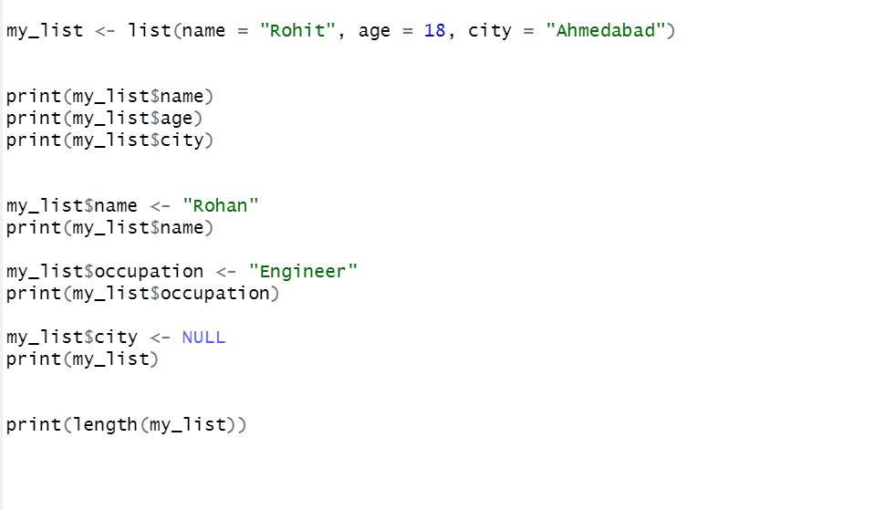

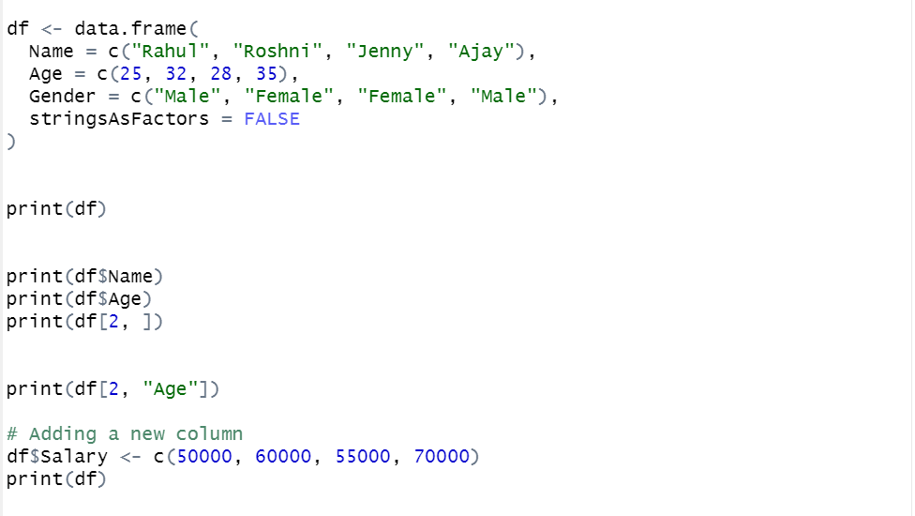

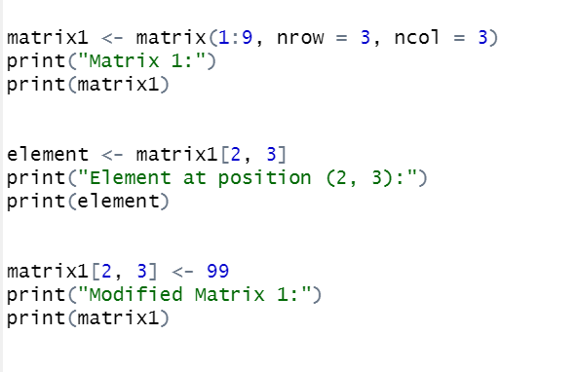

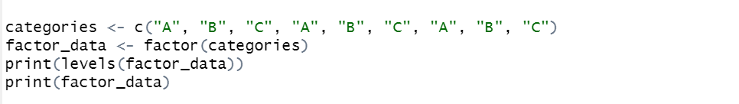

**Output:**

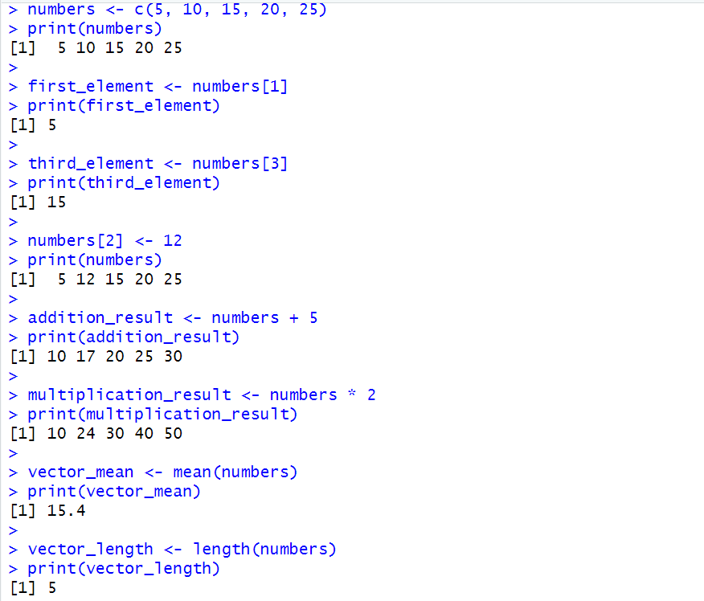

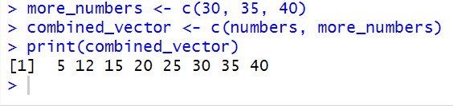

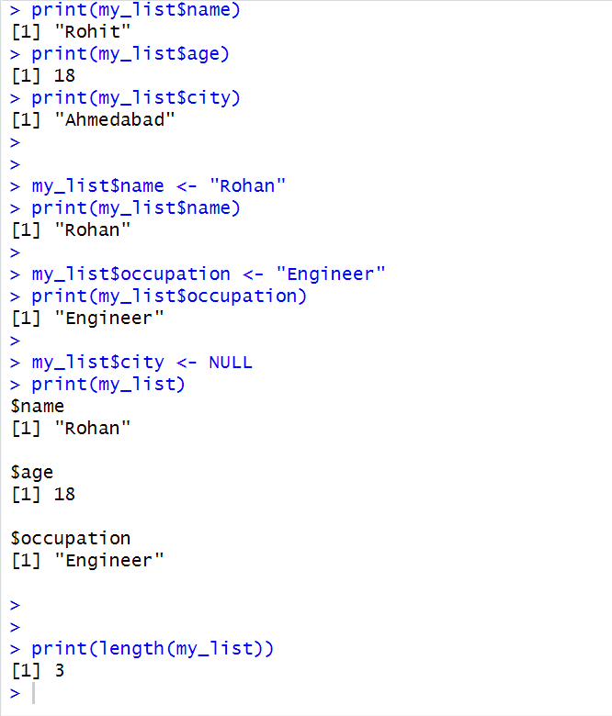

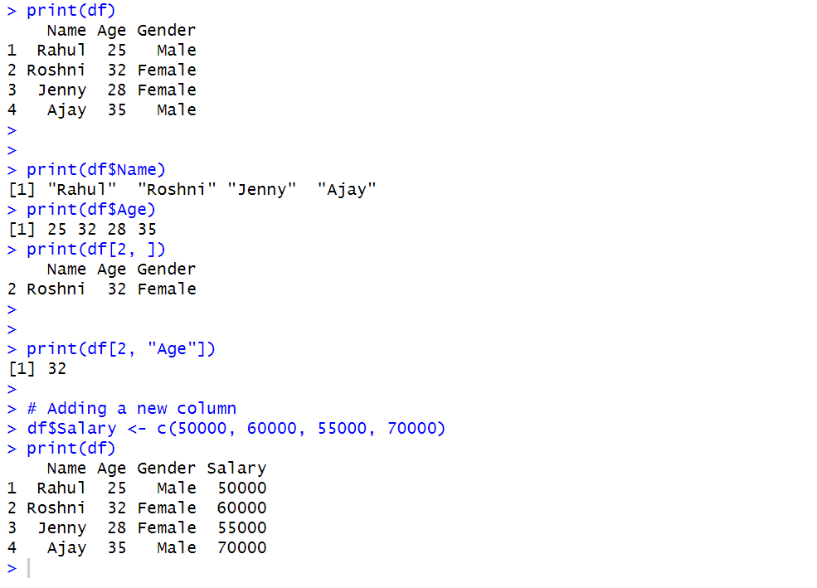

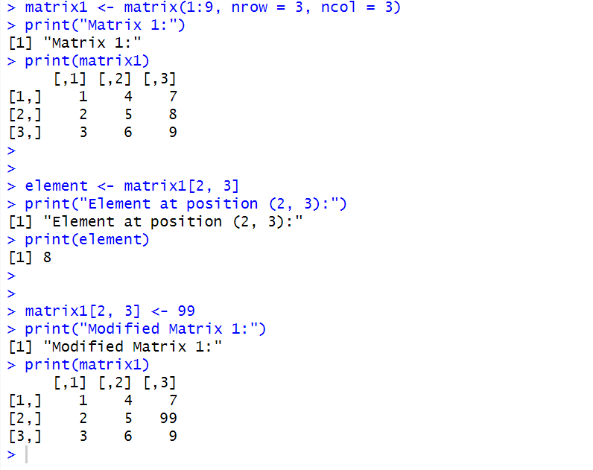

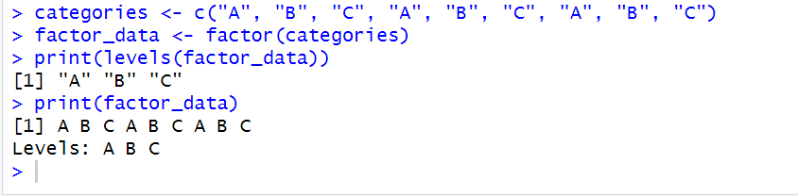

**Observation and Learnings:**

**_____________________________________________________________________________________________________________________________________________________________________________________________________________________________________________________________________.**